05 MVC의 역할과 실행 흐름

**MVC의 역할과 실행 흐름**

**미션**

다음 URL요청에 대한 응답 페이지를 만드시오.  
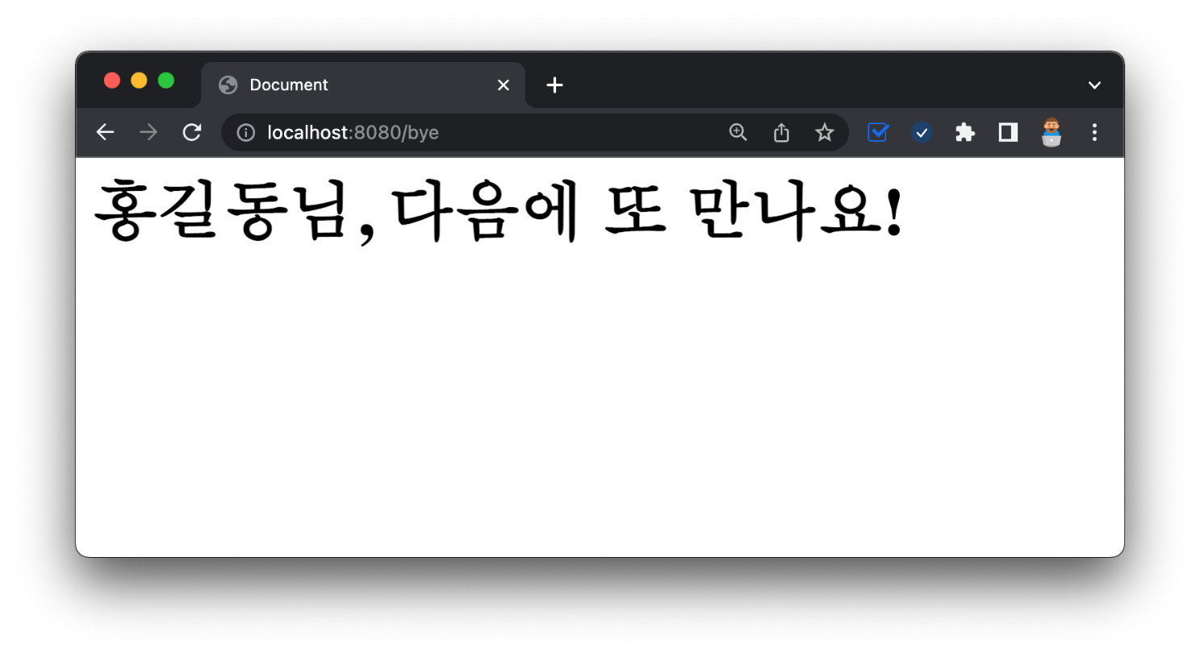

**리뷰 - 요청에서 응답까지**

../controller/FirstController

1. package com.example.firstproject.controller;
2. import org.springframework.stereotype.Controller;
3. import org.springframework.ui.Model;
4. import org.springframework.web.bind.annotation.GetMapping;
5. @Controller
6. public class FirstController {
7. @GetMapping("/hi")
8. public String niceToMeetYou(Model model) {
9. model.addAttribute("username", "hongpark");
10. return "greetings";
11. }
12. }

../templates/greetings.mustache

1. <html>
2. <head>
3. <meta charset="UTF-8">
4. <meta name="viewport"
5. content="width=device-width, user-scalable=no, initial-scale=1.0, maximum-scale=1.0, minimum-scale=1.0">
6. <meta http-equiv="X-UA-Compatible" content="ie=edge">
7. <title>Document</title>
8. </head>
9. <body>
10. <h1>{{username}}님, 반갑습니다.</h1>
11. </body>
12. </html>

**응용 - 또 다른 요청에 응답하기**

../controller/FirstController

1. package com.example.firstproject.controller;
2. import org.springframework.stereotype.Controller;
3. import org.springframework.ui.Model;
4. import org.springframework.web.bind.annotation.GetMapping;
5. @Controller
6. public class FirstController {
7. @GetMapping("/hi")
8. public String niceToMeetYou(Model model) {
9. model.addAttribute("username", "hongpark");
10. return "greetings";
11. }
12. @GetMapping("/bye")
13. public String seeYouNext(Model model) {
14. model.addAttribute("nickname", "홍길동");
15. return "goodbye";
16. }
17. }

../templates/goodbye.mustache

1. <html>
2. <head>
3. <meta charset="UTF-8">
4. <meta name="viewport"
5. content="width=device-width, user-scalable=no, initial-scale=1.0, maximum-scale=1.0, minimum-scale=1.0">
6. <meta http-equiv="X-UA-Compatible" content="ie=edge">
7. <title>Document</title>
8. </head>
9. <body>
10. <h1>{{nickname}}님, 다음에 또 만나요!</h1>
11. </body>
12. </html>

**🔥 구글링 훈련하기**

* 웹서버 요청 응답 과정
* MVC 패턴 장점